

network protocols and communications

Introduction to Networking and Security



September 29, 2019

Jamie lu

W0441213

Table of Contents

Introduction: 2

Chapter 2 Configure a Network Operating System 3

2.1.4.6 Navigating the IOS 3

Screenshot 1 of Activity 2.1.4.6 Accessing Devices 3

Screenshot 2 of Activity 2.1.4.6 Accessing Devices 4

2.2.3.4 Configuring Initial Switch Settings 5

Screenshot 1 of Activity 2.2.3.4 Configuring Initial Switch Settings 5

Screenshot 2 of Activity 2.2.3.4 Configuring Initial Switch Settings 6

2.3.2.5 Implementing Basic Connectivity 7

Screenshot 1 of Activity 2.2.3.5 Implementing Basic Connectivity 7

Screenshot 2 of Activity 2.2.3.5 Implementing Basic Connectivity 8

the CCNA Portable Command Guide 9

a) What is the function of the enable command? 9

b) How do you know that you’re in Privileged mode (also called EXEC-level mode)? 9

c) What command would list all of the **show** commands available? 9

d) What command would you use to set an IP address to an interface on a router? 9

2.4.1.2 Skills Integration Challenge 10

Screenshot 1 of Activity 2.4.1.2 Skills Integration Challenge 10

Screenshot 2 of Activity 2.4.1.2 Skills Integration Challenge 11

CASE STUDY: Sarah’s Wireless Network 12

12

Screenshot 1 of Sarah’s Wireless Network 12

Screenshot 2 of Sarah’s Wireless Network 13

Screenshot 3 of Sarah’s Wireless Network 14

# Introduction:

# Chapter 2 Configure a Network Operating System

## 2.1.4.6 Navigating the IOS

­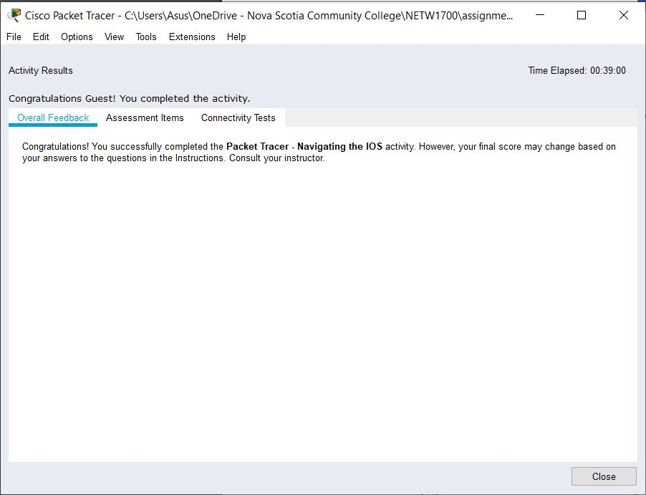

### Screenshot 1 of Activity 2.1.4.6 Accessing Devices

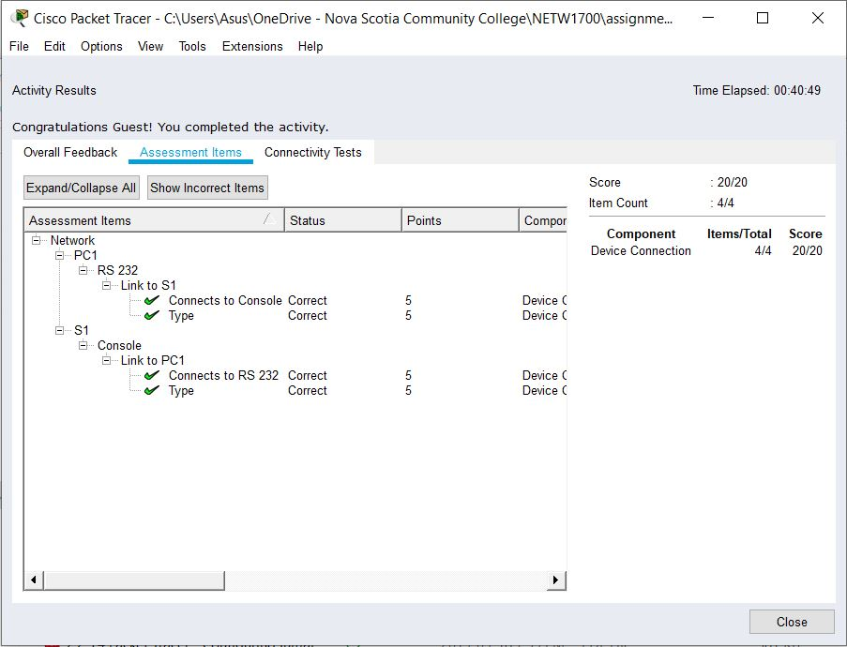

### Screenshot 2 of Activity 2.1.4.6 Accessing Devices

## 2.2.3.4 Configuring Initial Switch Settings

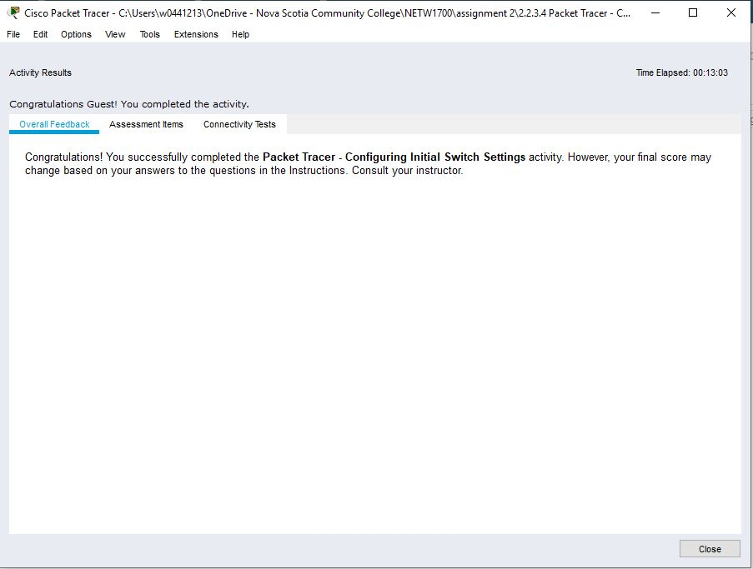

### Screenshot 1 of Activity 2.2.3.4 Configuring Initial Switch Settings

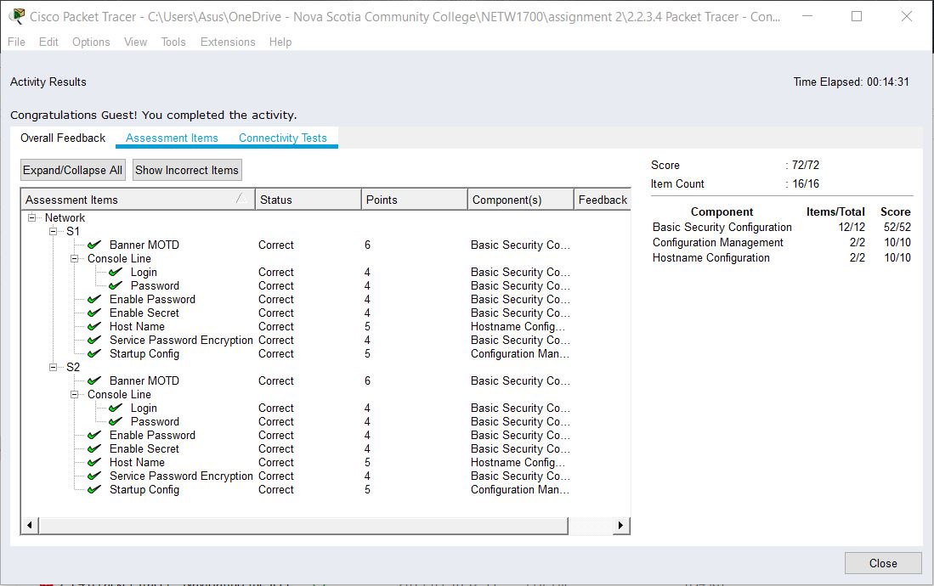

### Screenshot 2 of Activity 2.2.3.4 Configuring Initial Switch Settings

## 2.3.2.5 Implementing Basic Connectivity

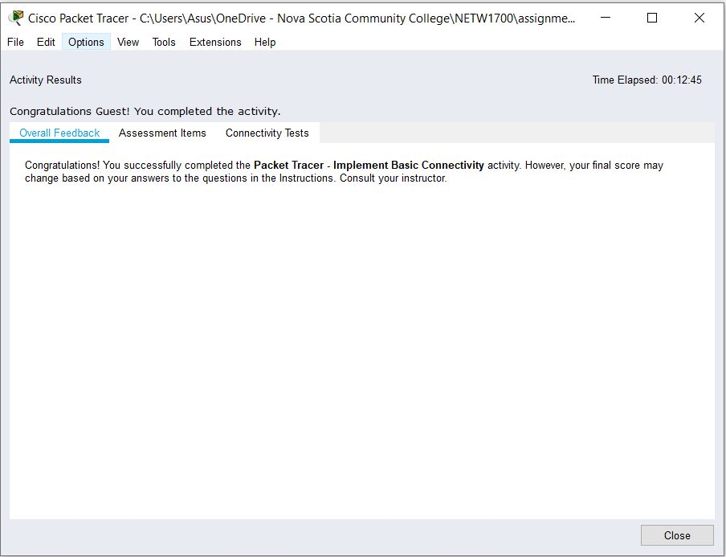

### Screenshot 1 of Activity 2.2.3.5 Implementing Basic Connectivity

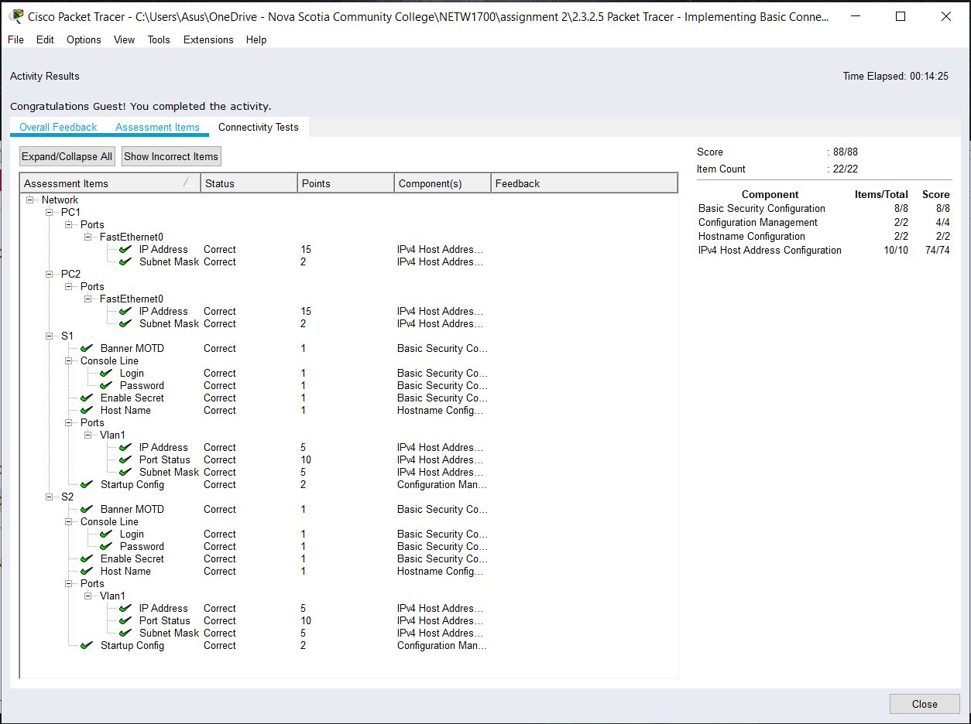

### Screenshot 2 of Activity 2.2.3.5 Implementing Basic Connectivity

# the CCNA Portable Command Guide[1]

## What is the function of the enable command?

* The enable command will open the Privileged EXEC mode wherein this mode will give additional commands.

## How do you know that you’re in Privileged mode (also called EXEC-level mode)?

* In order to identify if one is in Privileged mode, one can tell by the symbol ***#*.** The last character for the command prompt after the hostname is ***#*.** *(Example:* ***Switch#*** *or* ***S1#****)*

## What command would list all of the **show** commands available?

* The ***show?*** command would show all the show commands in the specific mode you are currently in.

## What command would you use to set an IP address to an interface on a router?

* In order to set an IP address to an interface on a router, one would have to use the ***interface*** command while in global configuration mode. The command prompt would then change to ***Switch(config-if)#*** which you would then type in the IP address and the subnet mask.

## 2.4.1.2 Skills Integration Challenge

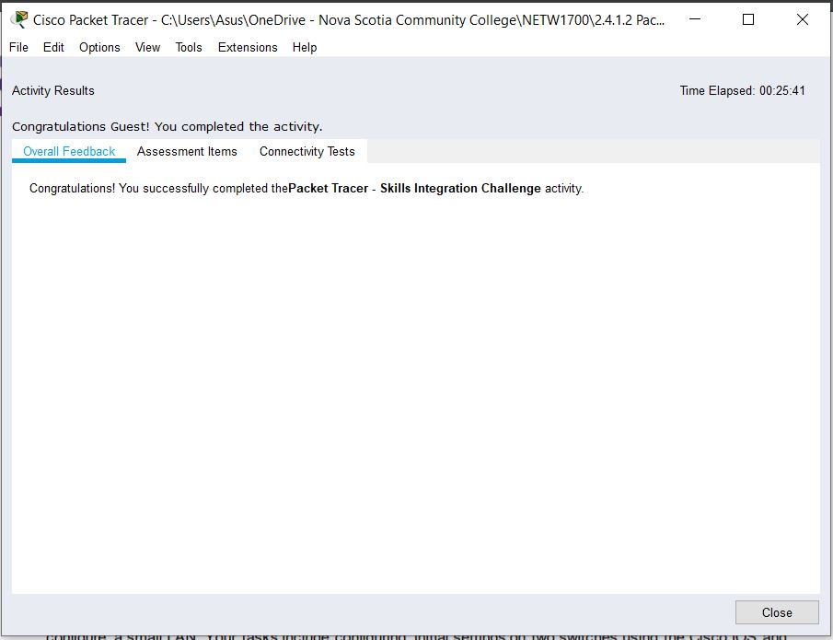

### Screenshot 1 of Activity 2.4.1.2 Skills Integration Challenge

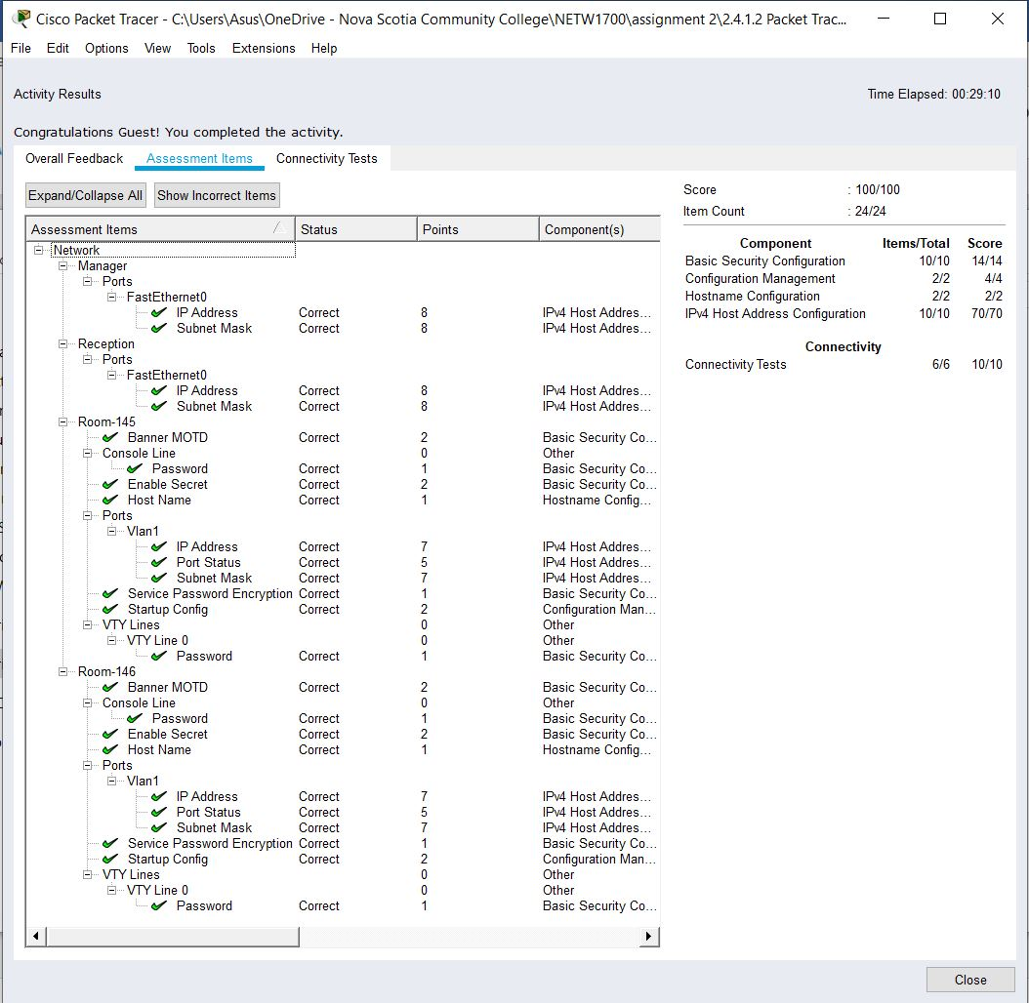

### Screenshot 2 of Activity 2.4.1.2 Skills Integration Challenge

# CASE STUDY: Sarah’s Wireless Network

# 

## Screenshot 1 of Sarah’s Wireless Network

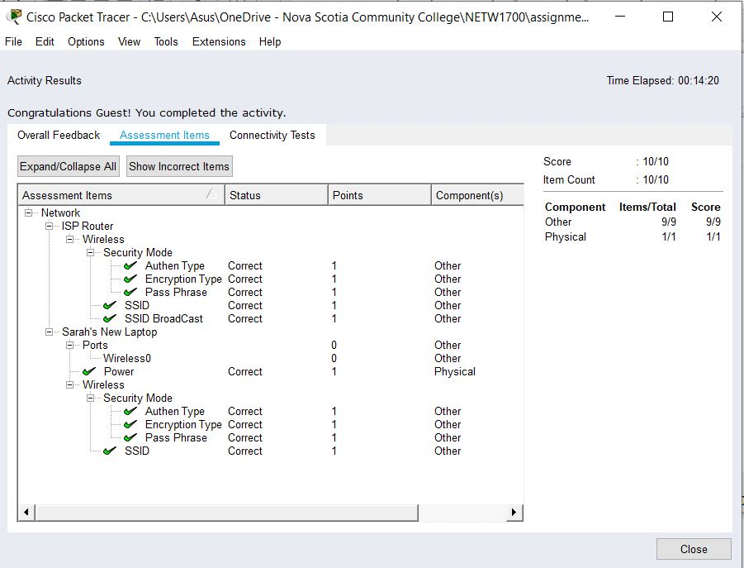

## Screenshot 2 of Sarah’s Wireless Network

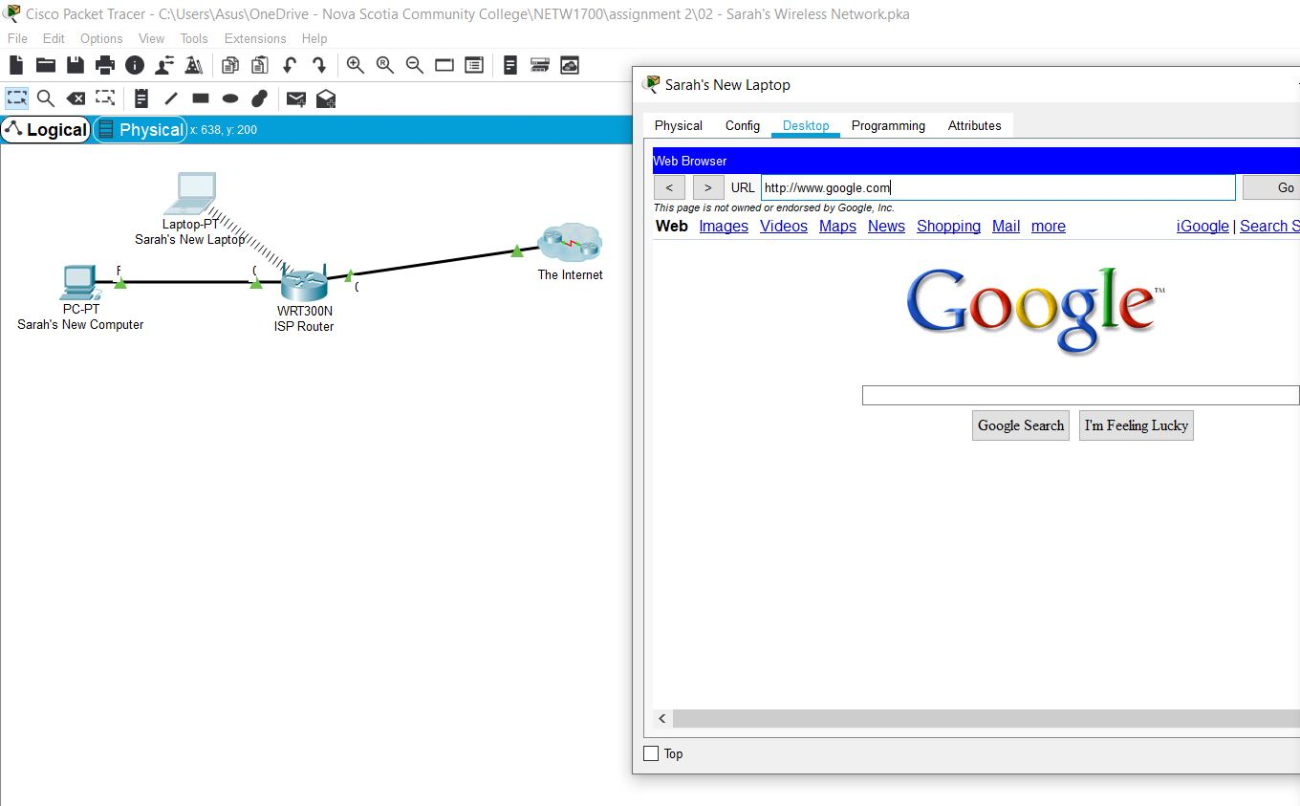

## Screenshot 3 of Sarah’s Wireless Network

# Works Cited

Cisco Networking Academy. (n.d.). *Introduction to Networks, Chapter 2: Configure a Network Operating System*. Retrieved September 19, 2019, from Cisco Networking Academy: https://static-course-assets.s3.amazonaws.com/ITN6/en/index.html#2

1. Questions are answered in my own words using information learned from the Packet tracer activities, the Introduction to Networks Chapter 2 in netacad (Cisco Networking Academy, n.d.)